Contents

Siebel certificates 1

Create keystore 1

NOTE 1

example 1

Generate CSR 1

example 1

Forward CSR to digicert 1

Get certificate in return 2

Get keytool-explorer 3

Download the keystore from server if generated in server 6

Inspect the certificate received from digicert 7

Extract root certificate from CA cert chain 8

Verify the extracted certificate 11

Import server certificate 12

Save the keystore before exiting or uploading to server 15

Create Truststore and Import trust certificate 15

Import root certificate 16

Import intermediate certificate 18

Save the keystore 20

Import server certificate from all other servers to enable communication 21

Upload the keystore and truststore 21

Update server.xml to point to trust store and keystore 22

Restart Siebel services 22

Test 22

# Siebel certificates

## Create keystore

keytool -genkey -alias **<ALIAS NAME>** -keyalg RSA -keysize 2048 -keystore <KEYSTORE NAME> -sigalg SHA256withRSA

### NOTE

Make a note of the alias name, the server certificate when received from digicert needs to be imported into this alias

### example

keytool -genkey -alias ty-sebtst7-ma-s_15-FEB-2023 -keyalg RSA -keysize 2048 -keystore siebelkeystore.jks -sigalg SHA256withRSA

## Generate CSR

keytool -certreq -alias <ALIAS NAME> -keyalg RSA -file <CSR FILENAME> -keystore <KEYSTORE NAME>

### example

keytool -certreq -alias ty-sebtst7-ma-s_15-FEB-2023 -keyalg RSA -file ty-sebtst7-ma-s_15-FEB-2023.csr -keystore siebelkeystore.jks

## Forward CSR to digicert

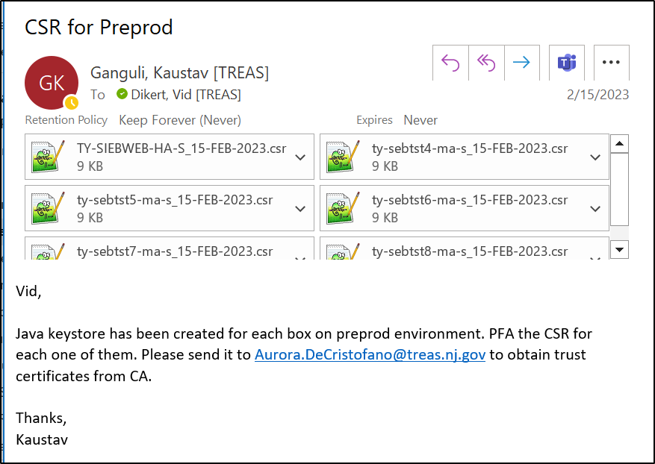

## Get certificate in return

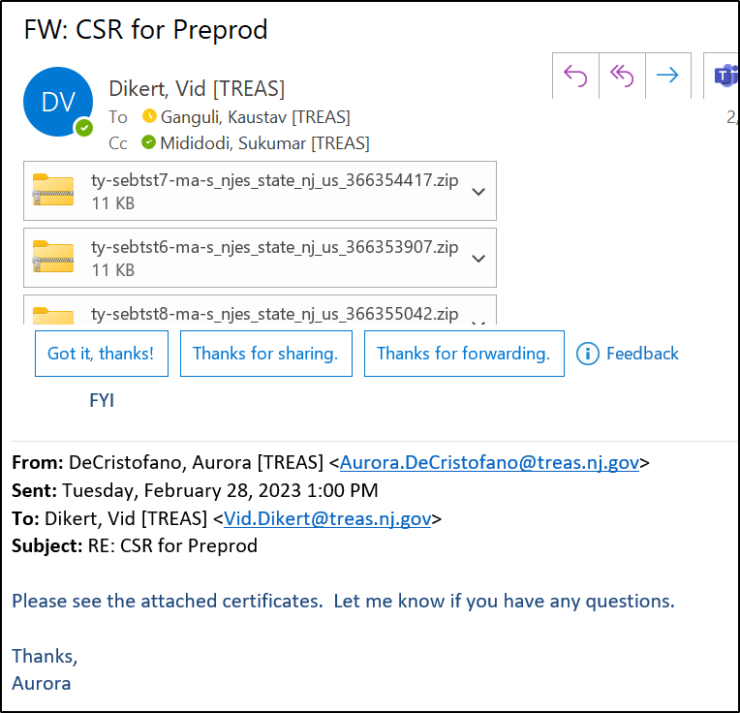

## Get keytool-explorer

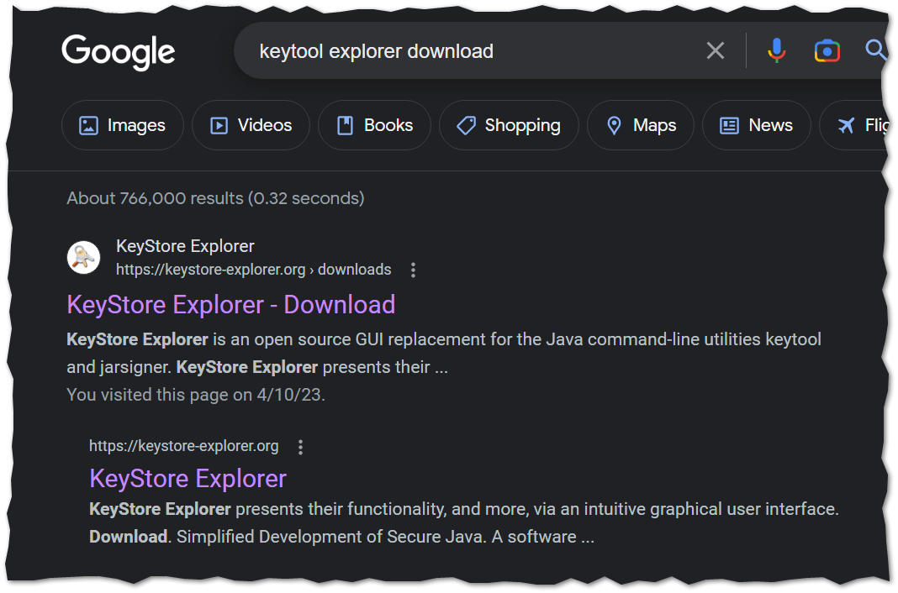

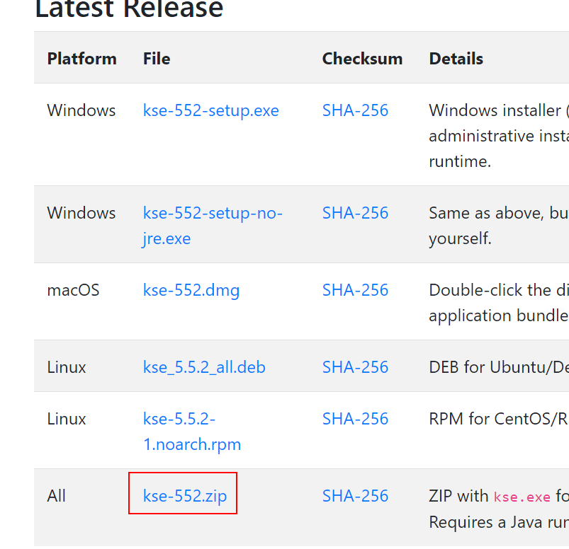

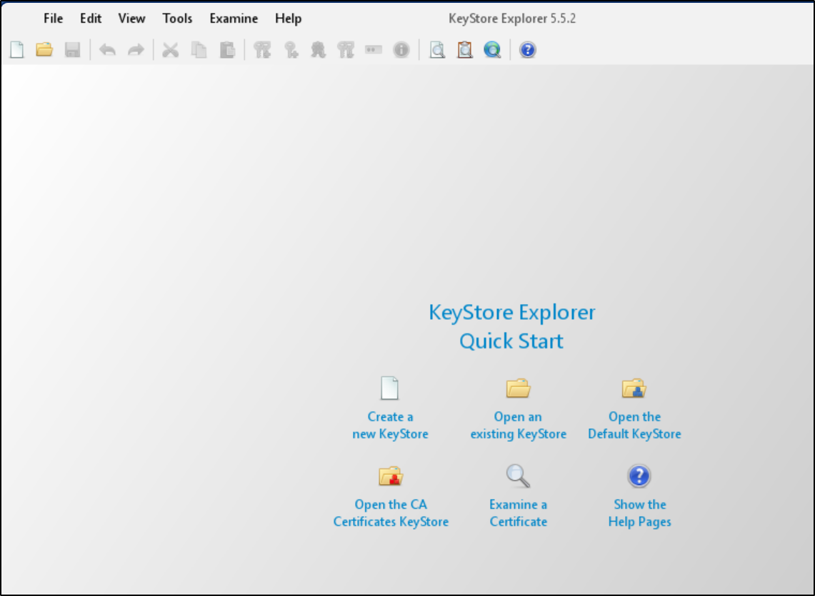

## Download the keystore from server if generated in server

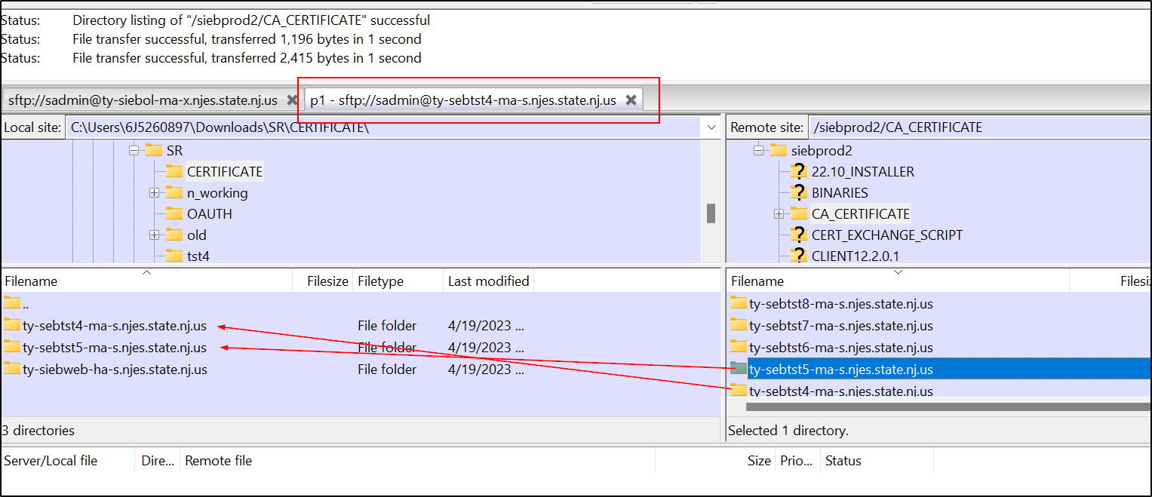

## Inspect the certificate received from digicert

Digicert sends two files. One trust certificate that has root and intermediate certificate chained together, and a server certificate (for which it received the CSR for), that has all three certificates chained together –

Inspect the certificate with windows “Crypto Shell Extension” to see the certificate path –

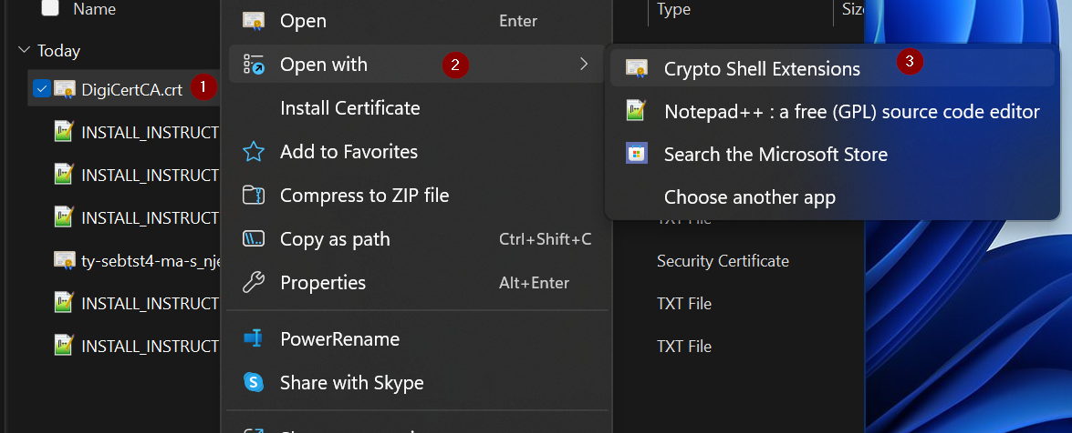

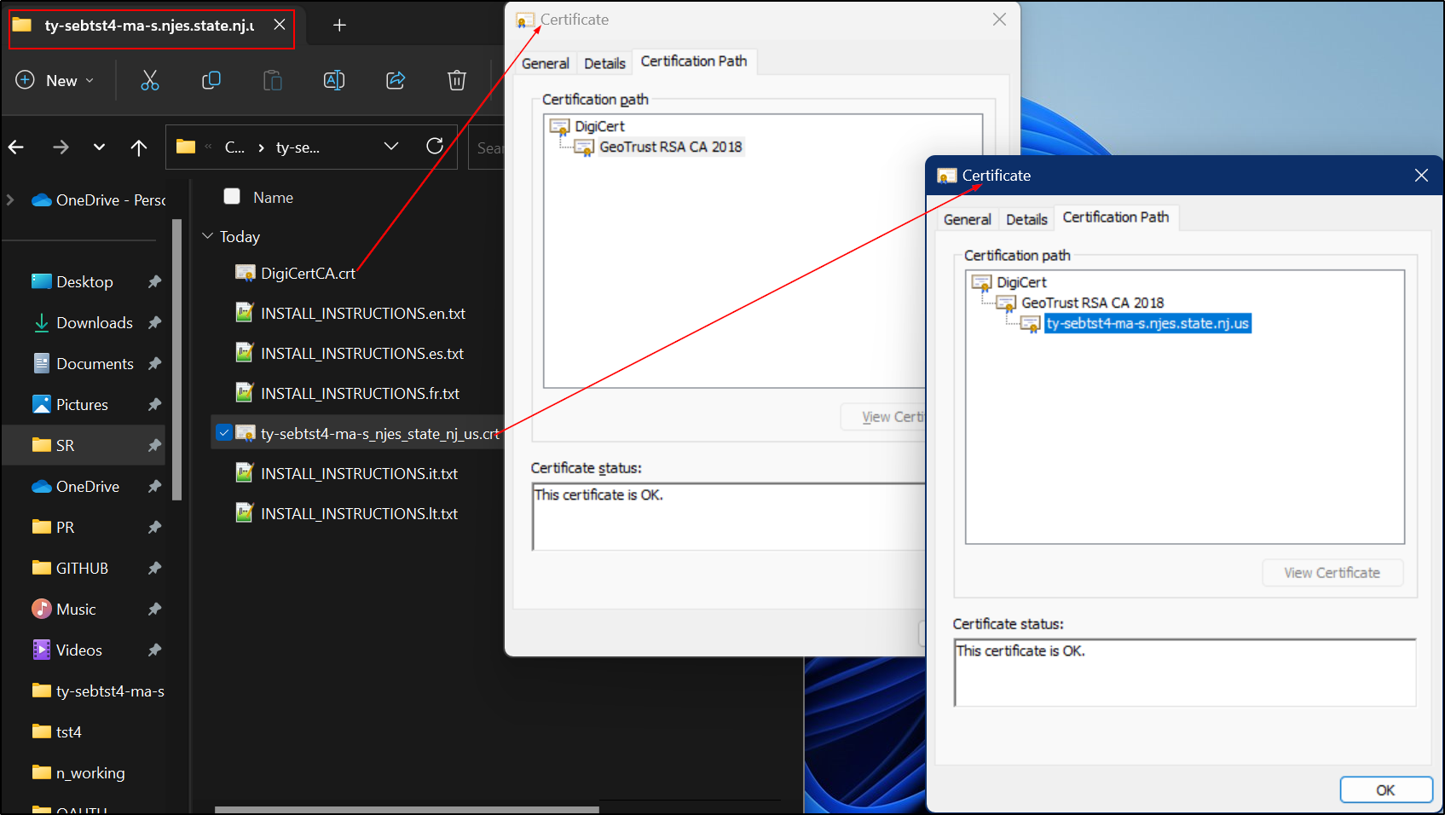

We would need the root certificate extracted in a separate file and then use keytool explorer to import. Without extracting the root certificate, keytool explorer only imports the intermediate certificate from “DigicertCA.crt” file

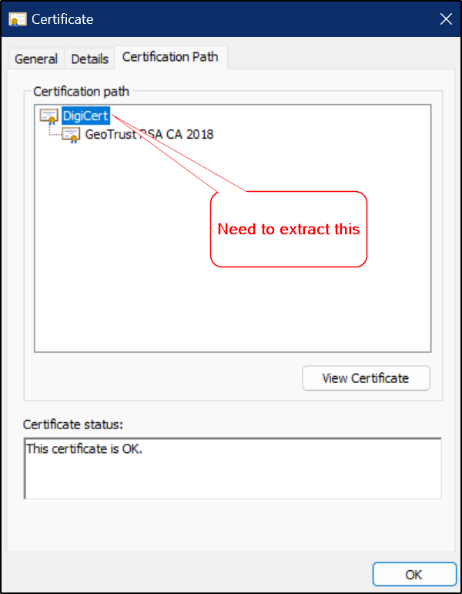

## Extract root certificate from CA cert chain

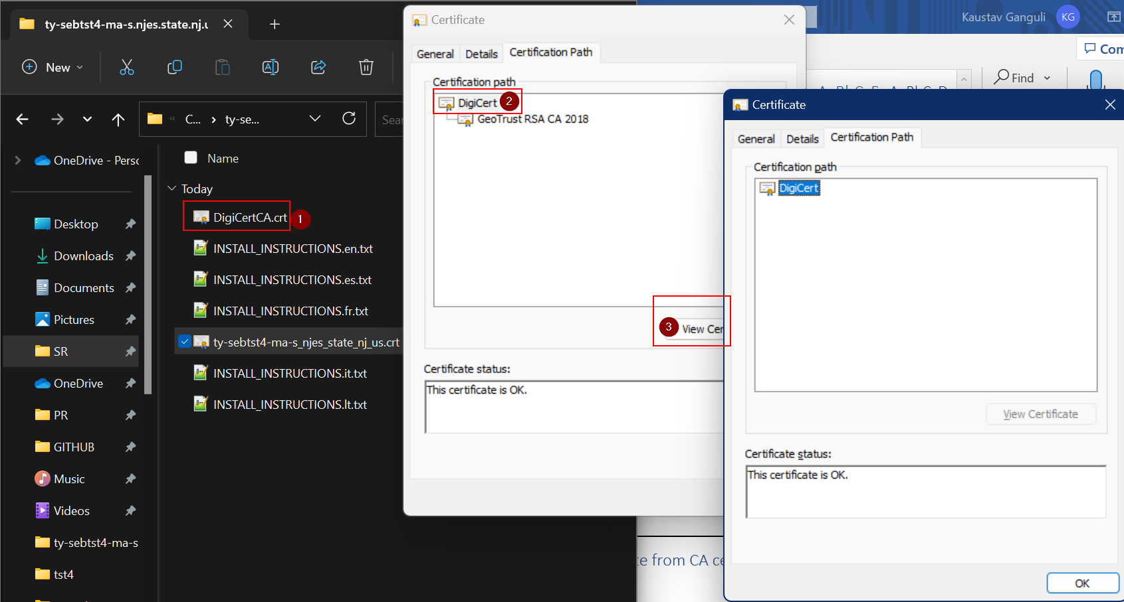

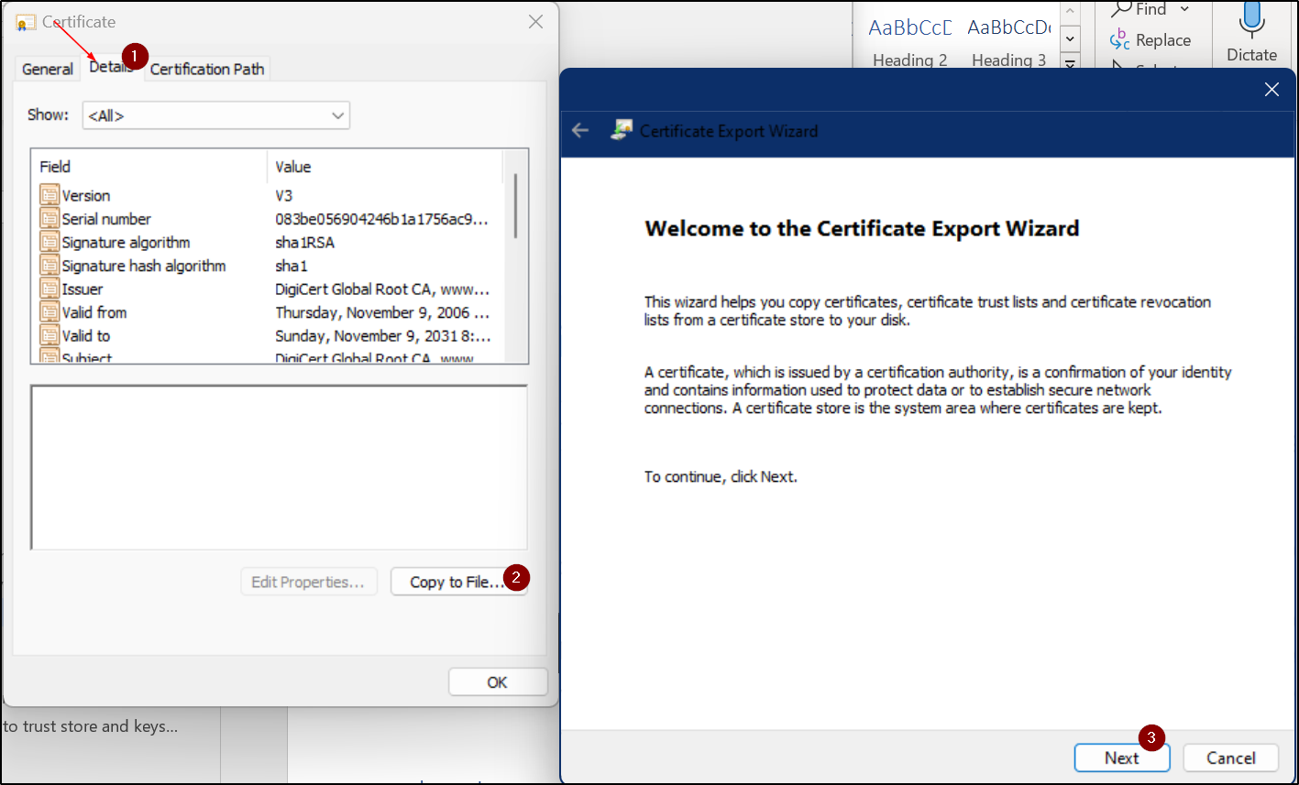

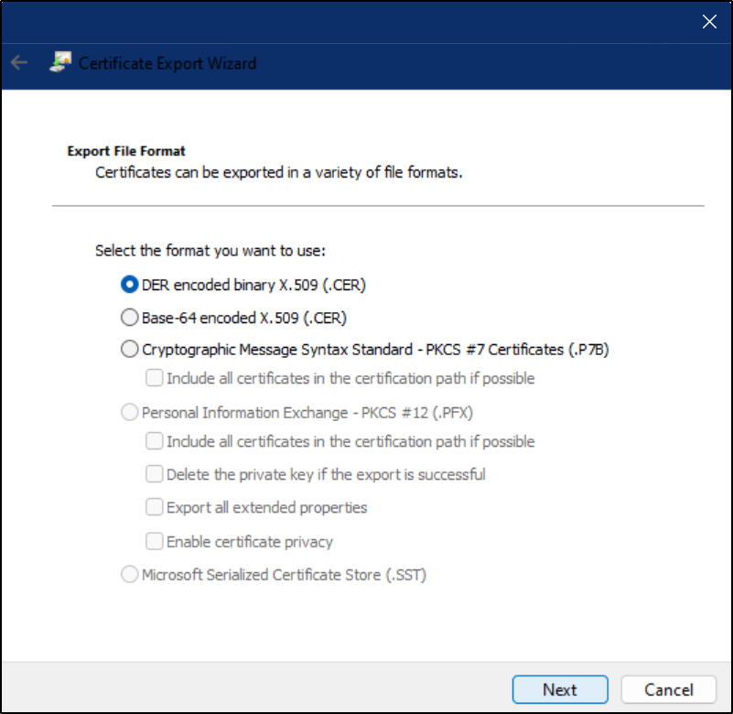

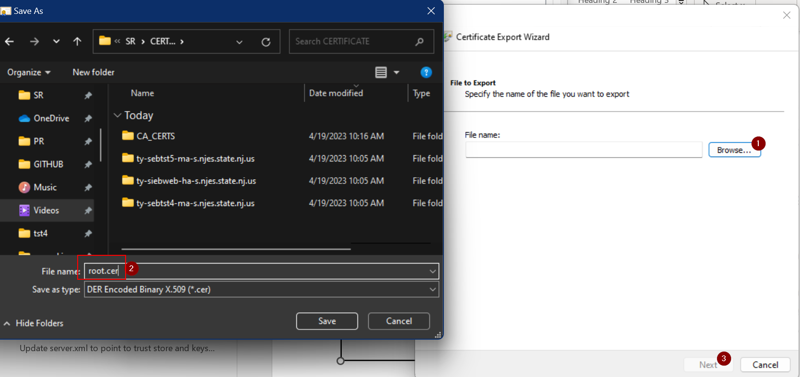



## Verify the extracted certificate

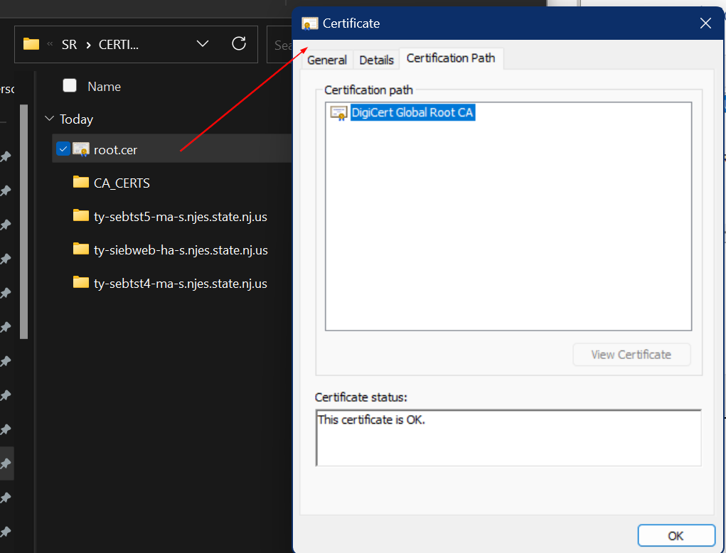

## Import server certificate

Open the keystore that was generated and downloaded

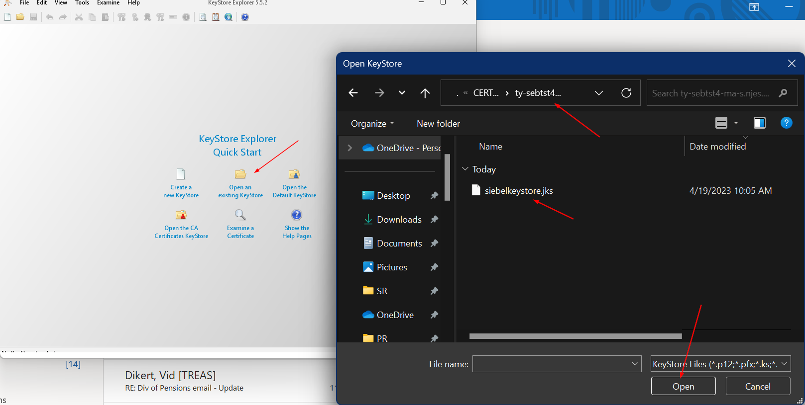

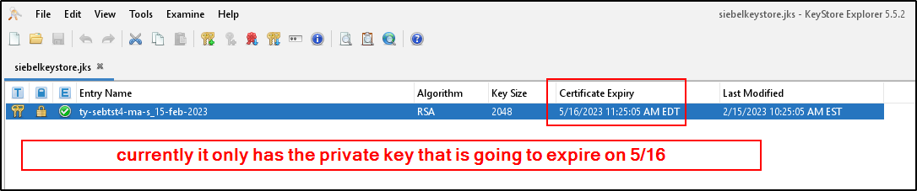

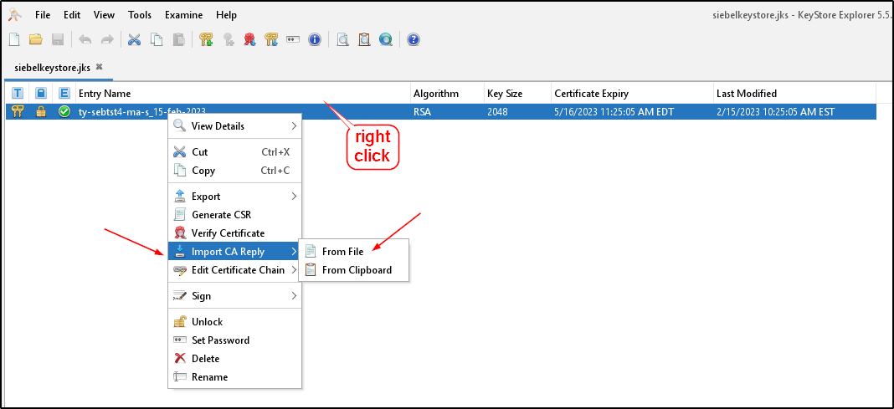

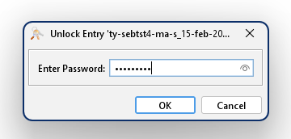

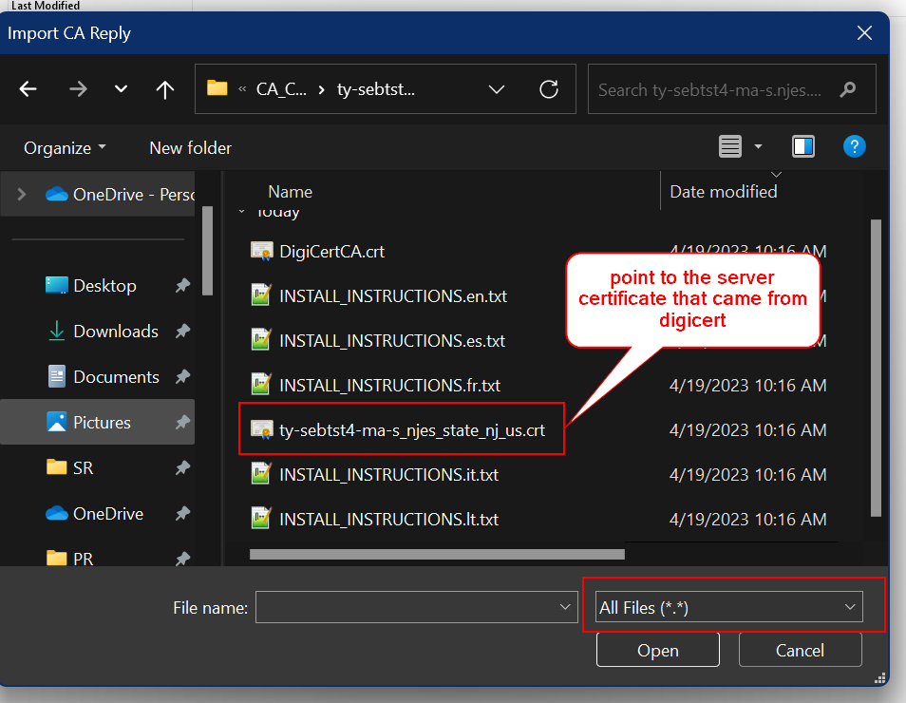

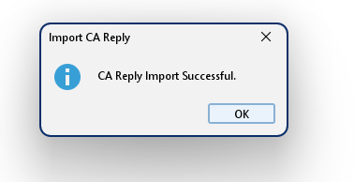

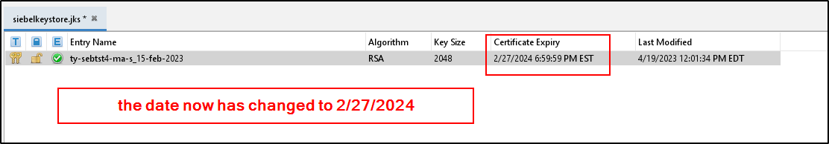

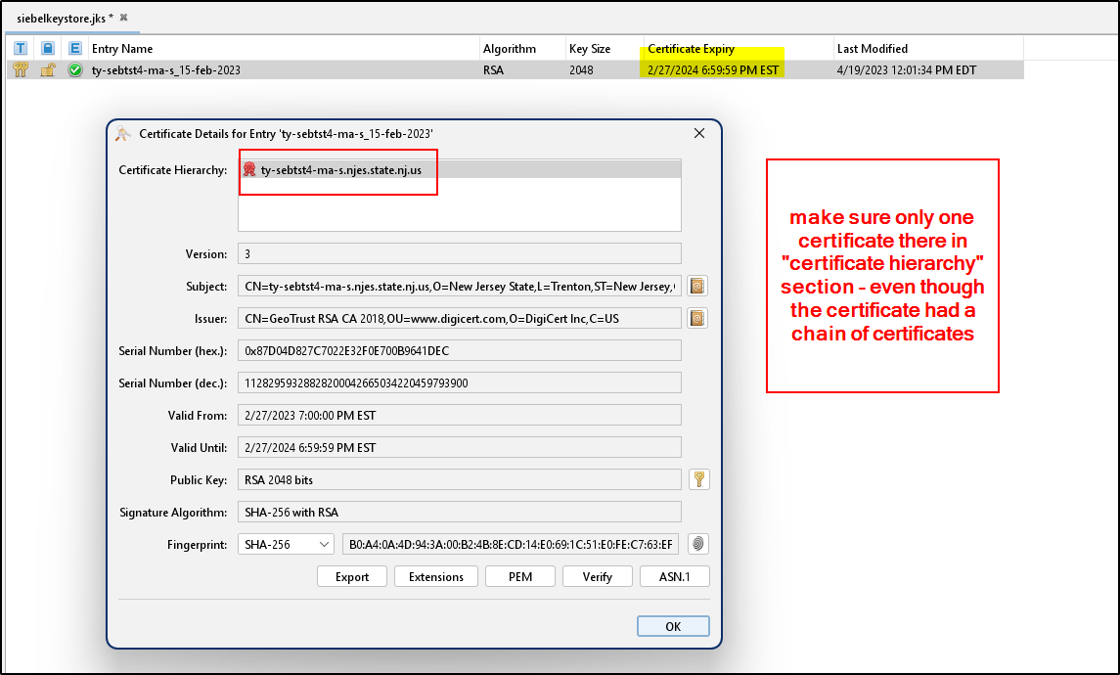

## Save the keystore before exiting or uploading to server

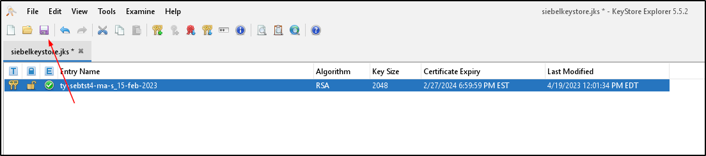

## Create Truststore and Import trust certificate

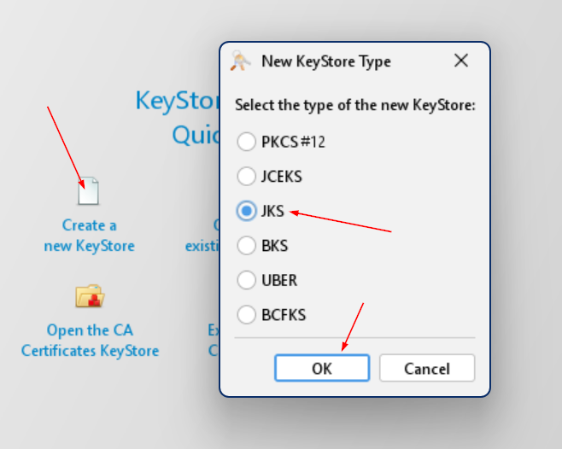

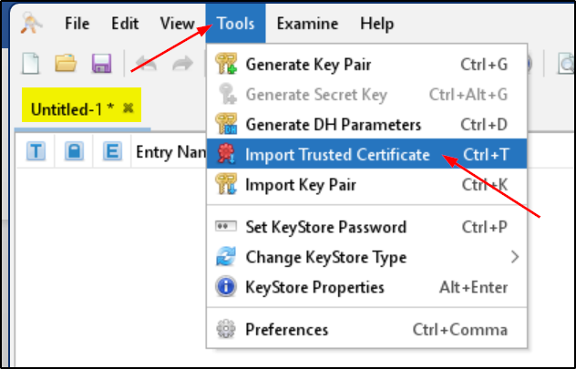

### Import root certificate

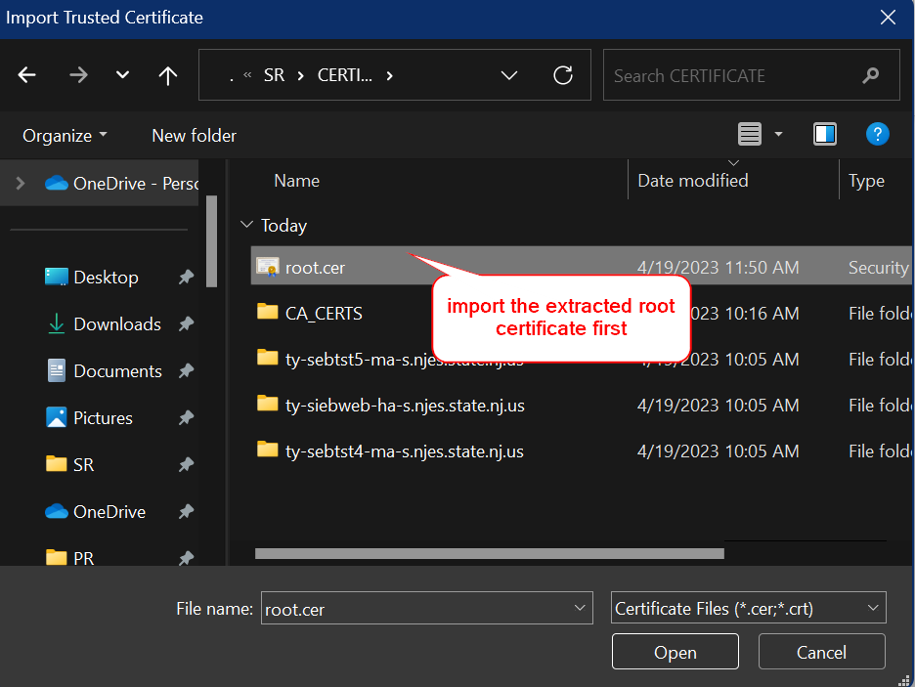

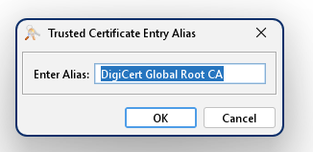

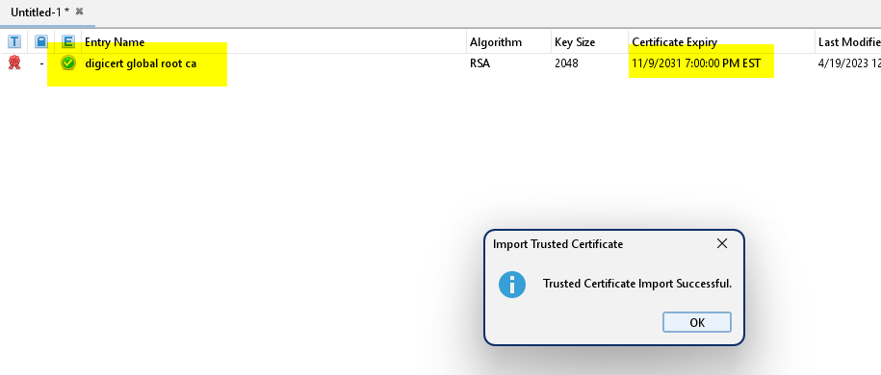

### Import intermediate certificate

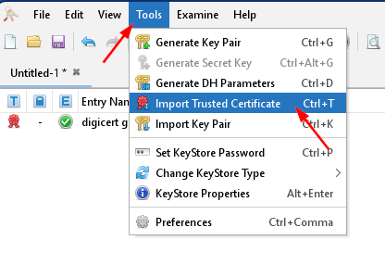

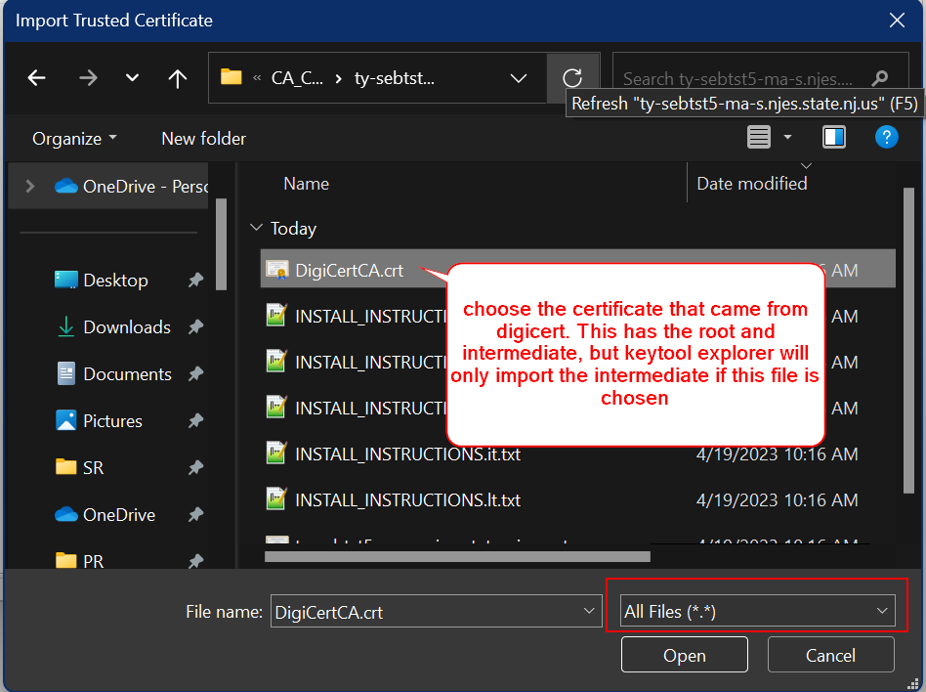

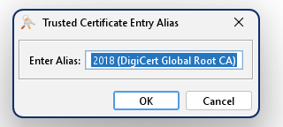

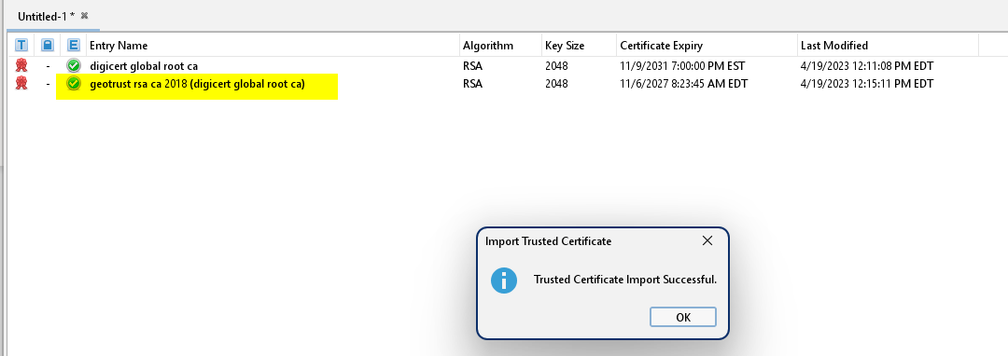

## Save the keystore

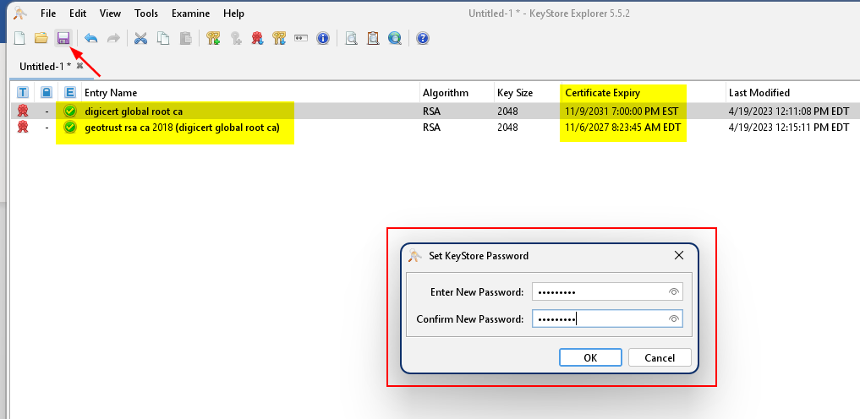

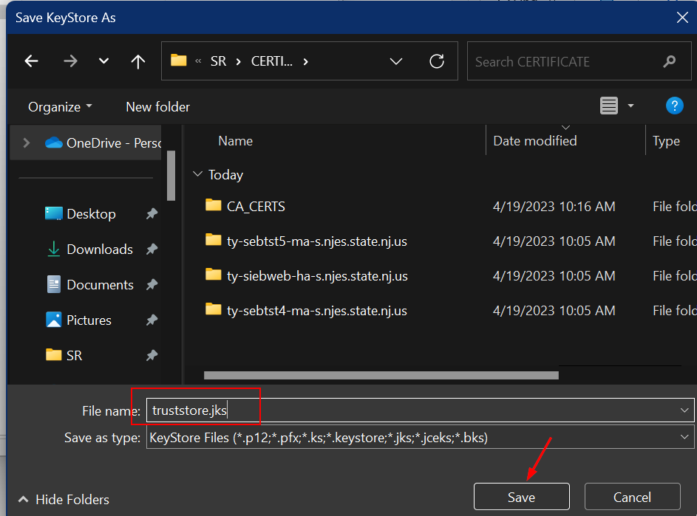

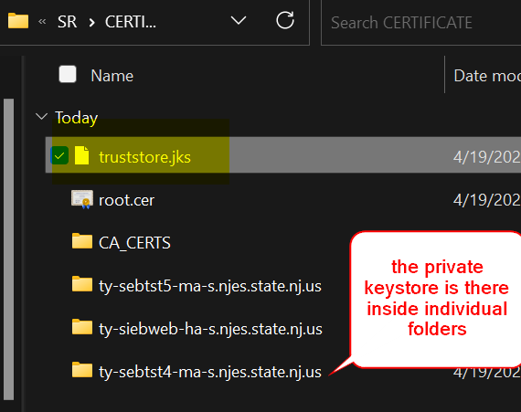

Renamed the “truststore.jks” to “siebeltruststore.jks” to match server configuration

## Import server certificate from all other servers to enable communication

## Upload the keystore and truststore

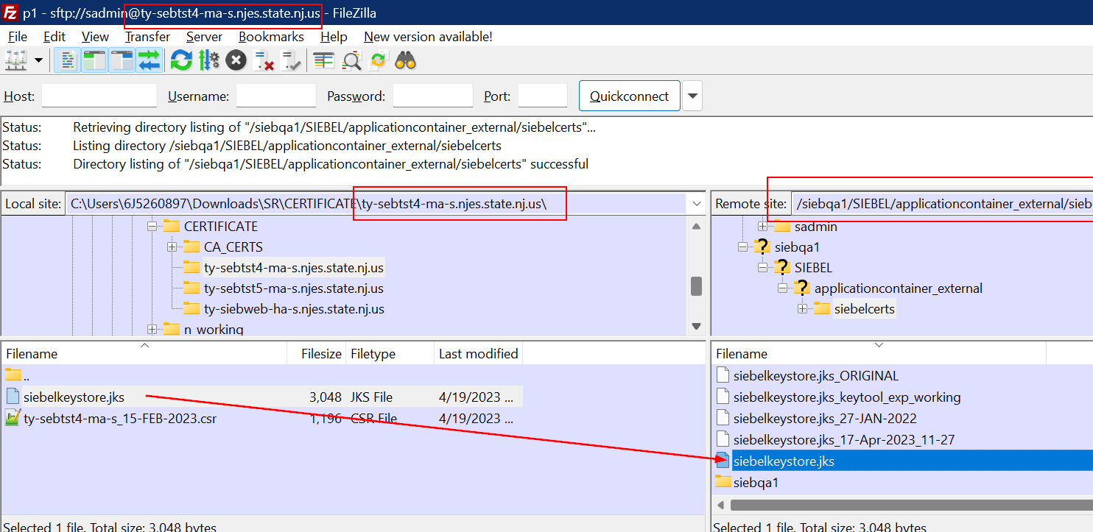

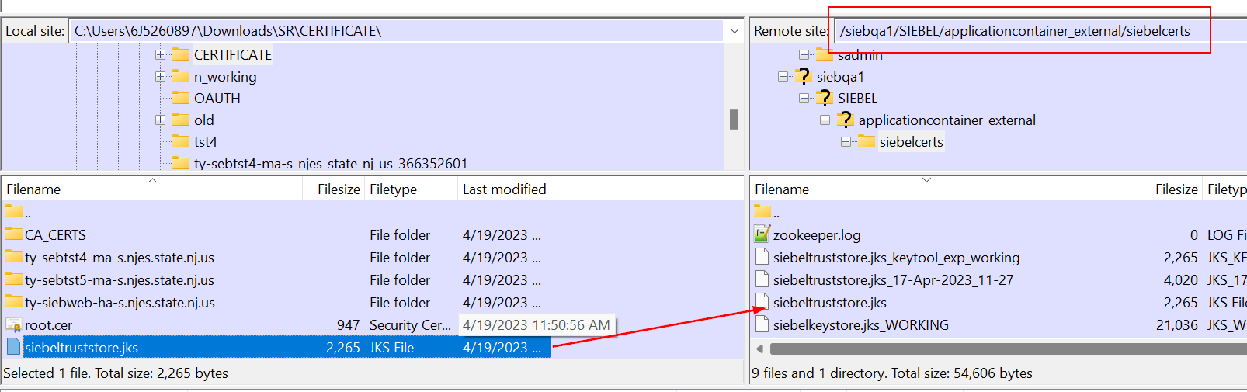

## Update server.xml to point to trust store and keystore

## Restart Siebel services

## Test

